Instructions for using Venus with Shelly Pro 3 EM

Step 1: Shelly Pro 3EM and Venus are on the same wifi, and make sure both devices have a good network signal.

Step 2: Set the‘RPC over UDP’port number on this page of Shelly APP to‘1010’.

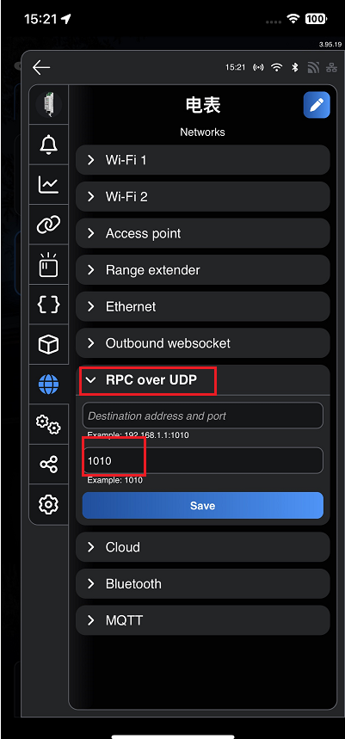

Step 3: Select the meter type as Shelly Pro 3EM via Marstek APP.

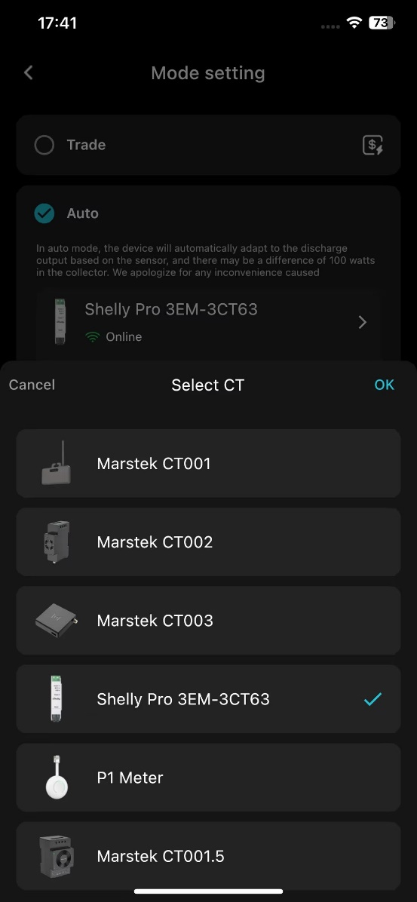

Step 4: Check if the connection is successful via Venus' LEDs or Marstek APP

