Mobile phone binding Shelly Pro 3 EM instructions

Step 1: Go to the App Store and download the software Shelly Smart Control

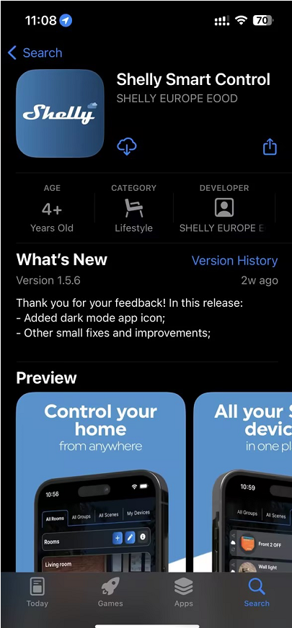

Step 2: Move your mobile phone as close as possible to the Shelly Pro 3 EM, and go to the homepage of the app to add the Shelly Pro 3 EM. During the process of adding the Shelly Pro 3 EM, you need to connect to the wifi, and the wifi in the example picture is ‘cszy’, so the user needs to connect to his/her own home wifi.

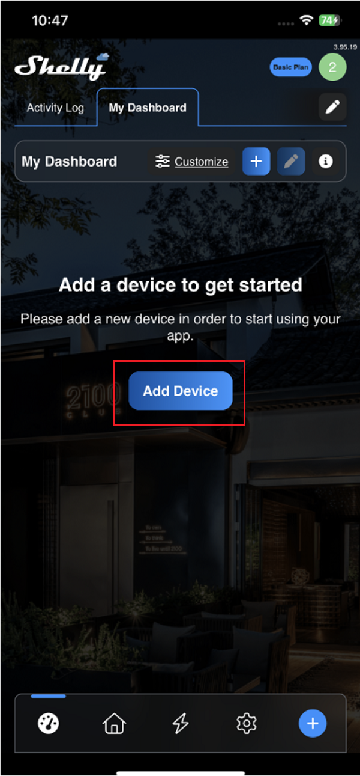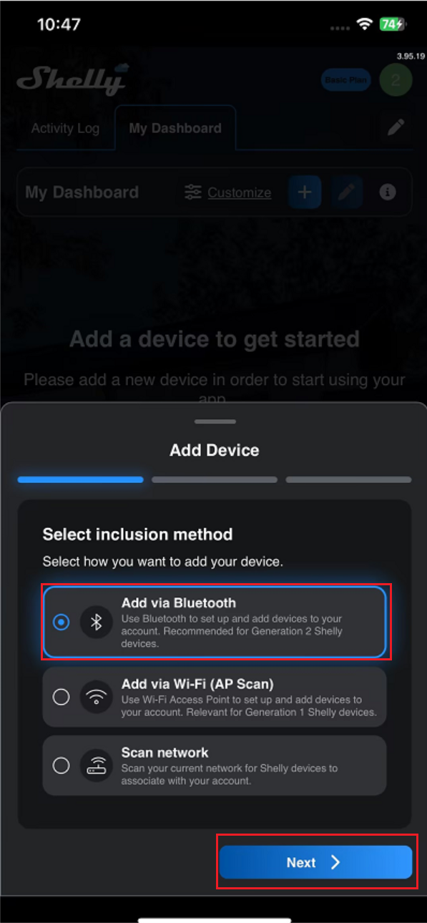

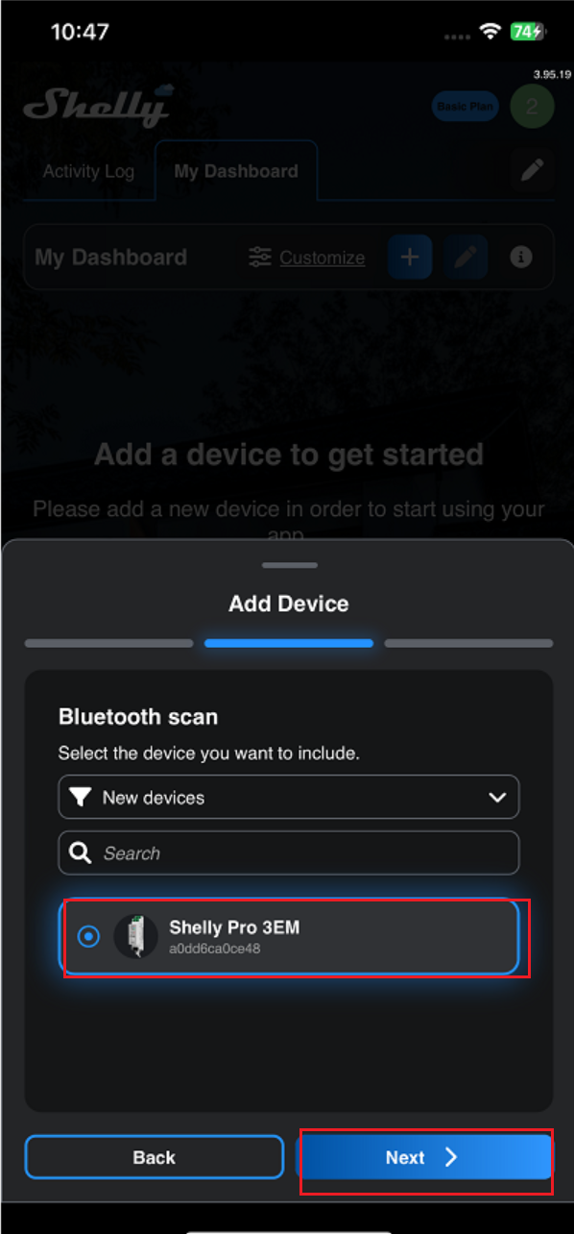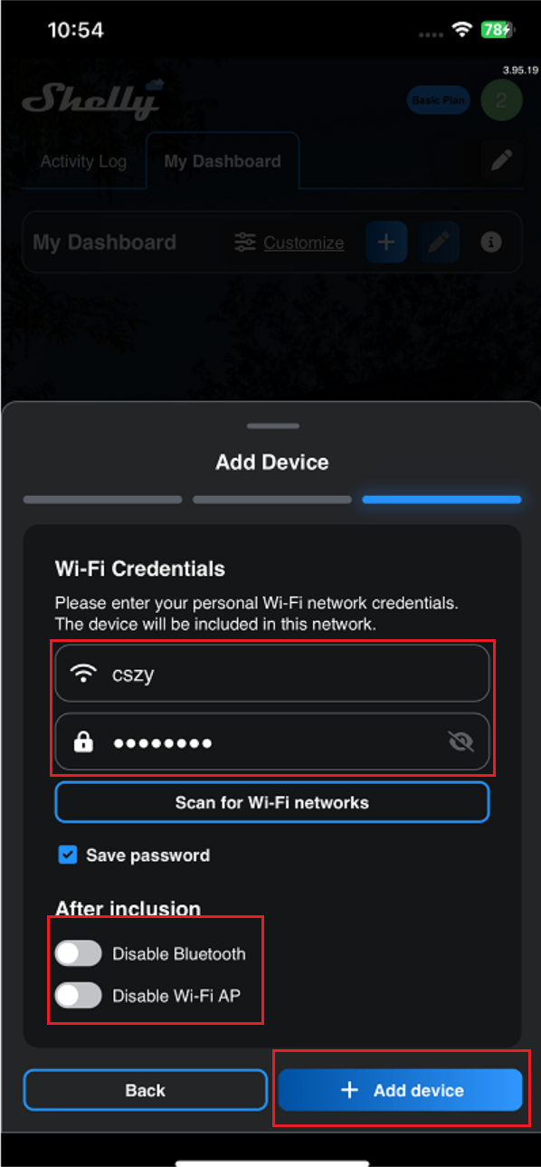

Step 3: Name the added Shelly Pro 3 EM and add it to the corresponding room to complete the binding. In the example, the name of the meter is ‘Q’ and the room added is ‘123’.

